**Numerical Method to PDEs Homework #4**

**Heng Chi 653987966**

**Problem.1**

The function f has the form:

$$f\left(x,y\right)=\frac{1}{{\left[{\left(x-x_{0}\right)}^{2}+{\left(y-y_{0}\right)}^{2}\right]}^{α}}$$

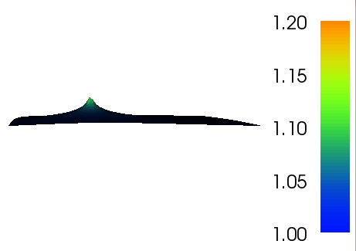 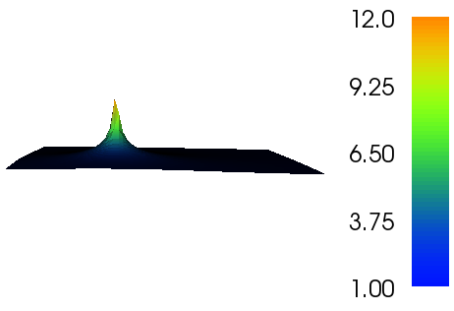

$α=0.01$ $α=0.25$

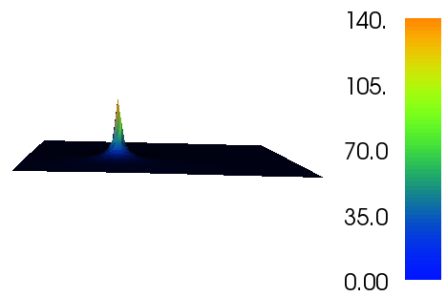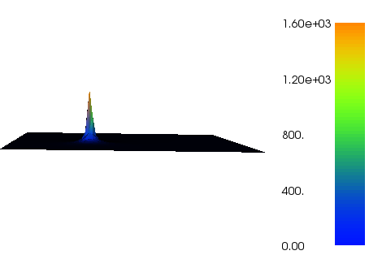

$α=0.5$ $α=0.75$

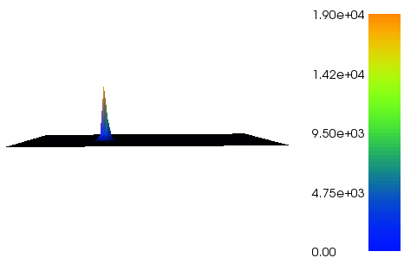

$$α=1$$

We can see from above figures that the function is singular at point $x=\left[\frac{1}{3},\frac{1}{3}\right]$ and the level of singularity increase as the parameter $α$ increases. Also, we note that the L2 integrability of the function depends on the parameter $α$. From mathematics, for the case of $α$ <=0.5, the function is a square integrable function, however, when $α$ >0.5, the function becomes not square integrable. Therefore, the error of the Lagrange interpolation will not converge to 0 for the case of $α$ >0.5 because the function $f$ is not in L2 space then. This can be shown by the table and figure below in terms of the rate of convergence.

The average convergence rate for different $α$ s:

|  |  |  |  |  |  |
| --- | --- | --- | --- | --- | --- |
| $$α$$ | 0.01 | 0.25 | 0.5 | 0.75 | 1 |
| Averaged rate of convergence in L2 error norm | 0.97948333 | 0.499928503 | -9.16E-06 | -0.500001017 | -1.0000001 |

**Problem 2**

Plots of solutions (‘exact solution 400*400’ and one approximated solution):

$α=0.01$

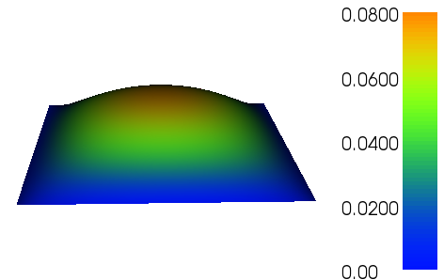 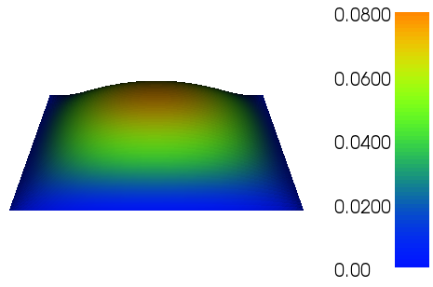

‘Exact solution’ refined approximated solution

$α=0.25$

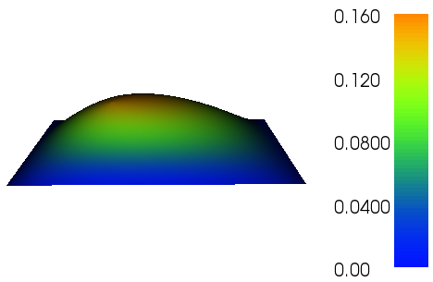 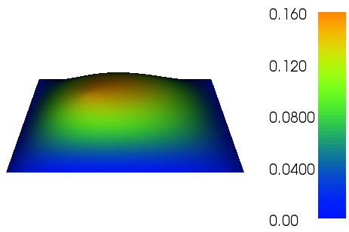

‘Exact solution’ refined approximated solution

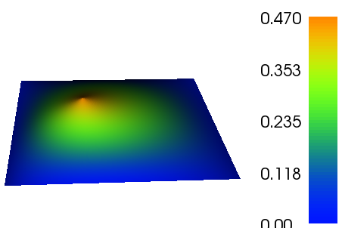 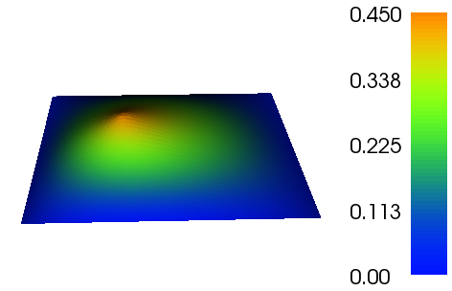

‘Exact solution’ refined approximated solution

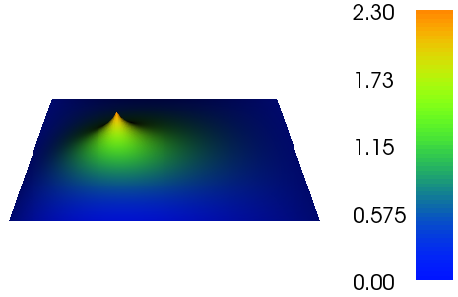 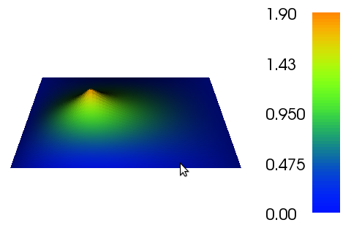

‘Exact solution’ refined approximated solution

$α=1$

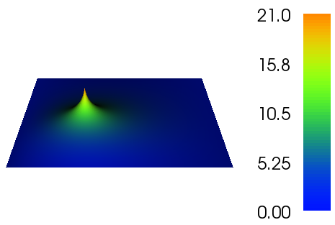 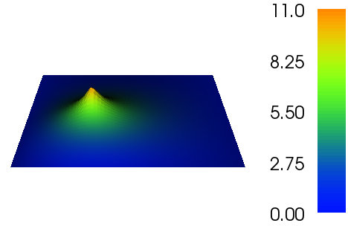

‘Exact solution’ refined approximated solution

$α=2$

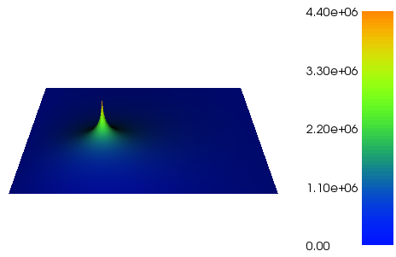 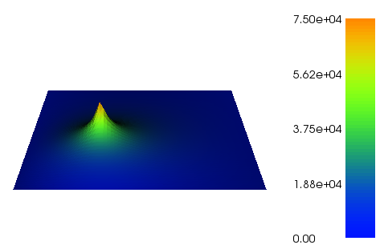

‘Exact solution’ refined approximated solution

Using the function given in problem 1 as a right hand side of the Poisson’s Equation, we solve the Poisson Equation over a unite square domain with homogenous Dirichlet boundary condition. First of all, a very fine mesh is used as an ‘exact solution’. Using the ‘exact solution’ we can compute the L2 and H1 norm of the errors with mesh refinement. The table and figure are shown below:

|  |  |  |  |  |  |  |
| --- | --- | --- | --- | --- | --- | --- |
| $$α$$ | 0.01 | 0.25 | 0.5 | 0.75 | 1 | 2 |
| L2 errornorm | 1.996706397 | 1.83392447 | 1.252696327 | 0.731162077 | 0.37802832 | 1.18E-02 |
| H1 errornorm | 0.99220701 | 0.996618677 | 0.92371057 | 0.569324163 | 0.25951405 | -0.08802698 |

From the results shown above, we can conclude that the square integrability of the right hand side affected the convergence of the FEM solution. If the right hand side is not square integrable (for the case of $α>0.5$), even a very fine mesh will yield very large errors and convergence rate is very low and even not converging.

For the case of $α$ being very small (0.01) for example, the convergence rate is very close to the analytical convergence rate: 2 for L2 errornorm and 1 for H1 errornorm.

**Problem 3.**

The exact solution is given by



In polar coordinates, the Laplacian operator is given by



where

 and 

gives the following result





Based on the math above, the exact solution u is the solution to a Laplace equation.

Why the solution is not in H2?

Because the domain is not convex and not smooth.

Solution Plots:

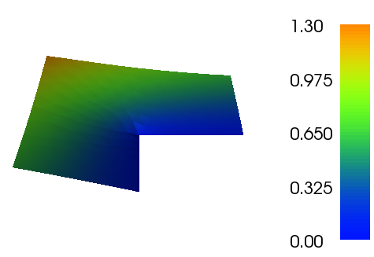 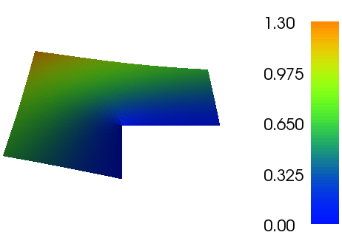

Mesh refinement level 1 Mesh refinement level 2

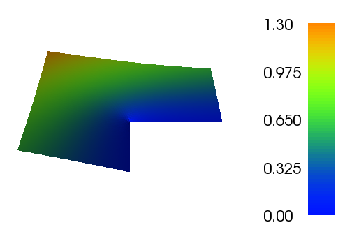 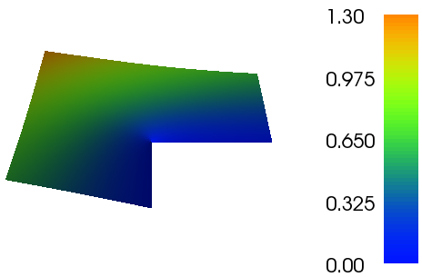

Mesh refinement level 3 Mesh refinement level4

The convergence of the FEM solution in L2 error is listed in table below:

|  |  |  |  |  |
| --- | --- | --- | --- | --- |
| hmax | 0.28743629 | 0.14371815 | 0.07185907 | 0.03592954 |
| L2 error norm | 5.92E-03 | 2.40E-03 | 9.70E-04 | 3.91E-04 |
| Convergence rate | 1.30217685 | 1.30644375 | 1.31201036 |  |

**Problem 4**

In the last problem, we try to solve the Poisson problem by means of mixed FEM method, which contains two unkown fields. One is an unknown vector field q and another is an unknown scalar field u. For the sake of brevity, the equations are not listed here. All the equations are implemented in Dophin exactly as what gives in the problems statement.

For the unknown field q, two test function spaces are used. The first one is Lagrange space of order (H(1)) and the second one is the Raviart-Thomas space (H(div)). The scalar field is assumed in constant space (DG of order 0). The final numerical results are shown as below:

1. Exact solution for u:

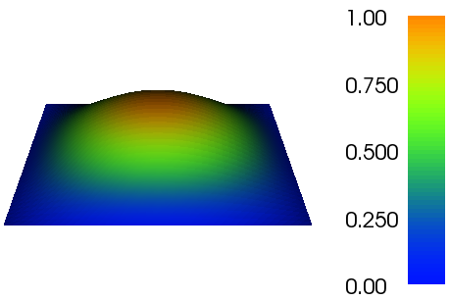

1. For test function q in H(1) space (40*40 mesh on a unit square):

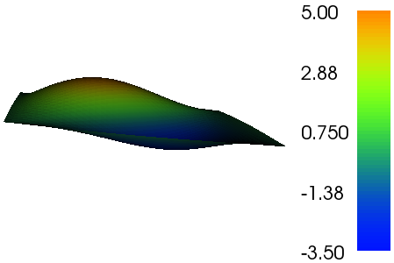 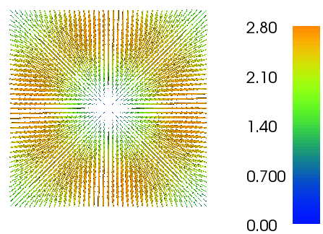

Scalar field u vector field q

1. For test function q in H(div) space (40*40 mesh on a unit square):

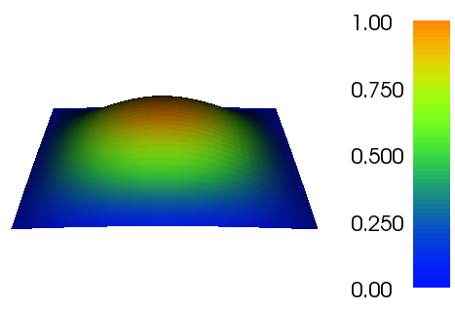 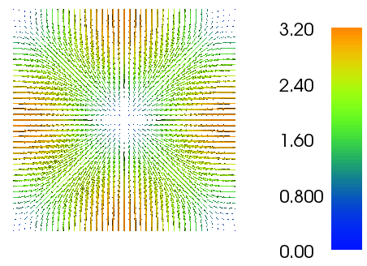

Moreover, the L2 error norm and convergence rate of u to the exact solution for different function space of q is computed and listed below:

|  |  |  |  |  |
| --- | --- | --- | --- | --- |
| h | 0.17767767 | 0.08838835 | 0.04419417 | 0.02209709 |
| Lagrange |  |  |  |  |
| L2 error norm | 0.06680054 | 0.0329013 | 0.01638475 | 0.00818403 |
| Rate | 1.02171485 | 1.00579079 | 1.00147153 |  |
| Raviart-Thomas |  |  |  |  |
| L2 error norm | 0.4095147 | 0.83293466 | 1.6764971 | 3.35871091 |
| Rate | -1.02428808 | -1.00917476 | -1.00245764 |  |

From obvervations, we note that for the case of assume q in Raviart-Thomas, the numerical solution u converge to the exact value. However, for the case of assuming q in Lagrange vector space, the numerical solutions of u do not converge to the exact u, on the contrary, the numerical solutions of u diverge from the exact as the mesh get refined.